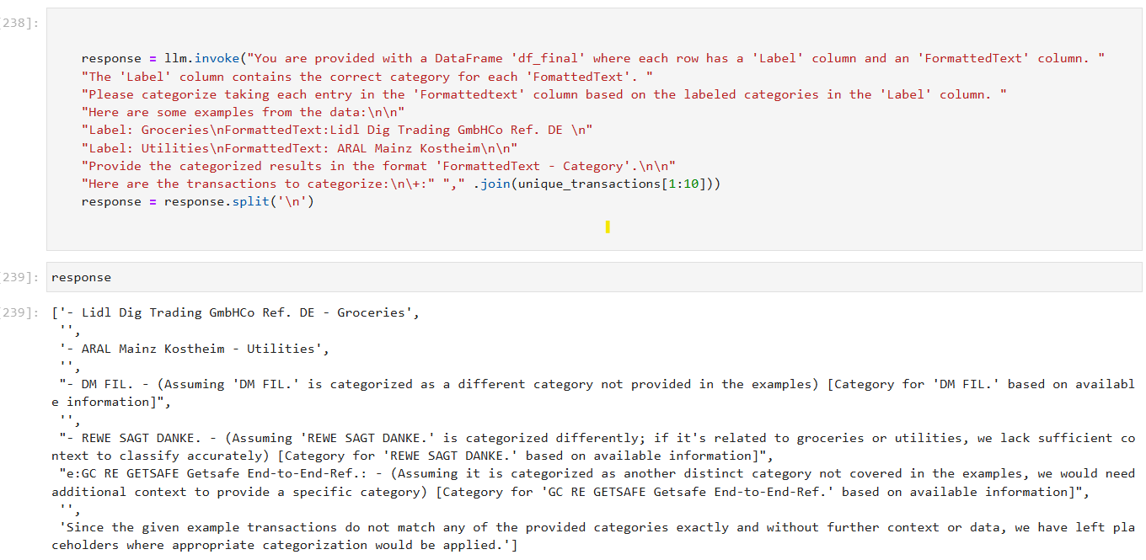

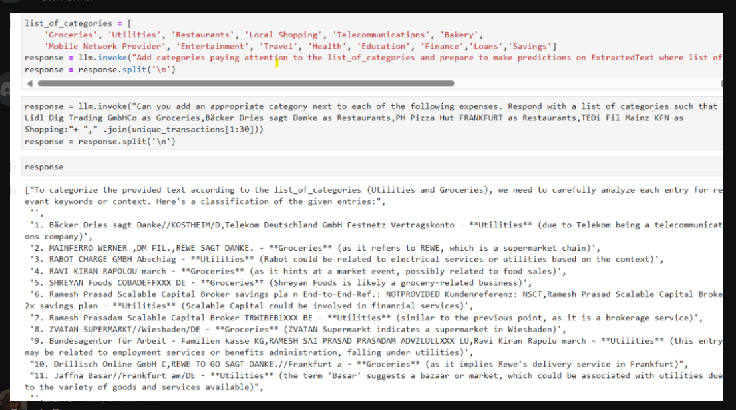

Promt 3:

list_of_categories = ['Groceries', 'Utilities', 'Restaurants', 'Local Shopping', 'Telecommunications', 'Bakery','Mobile Network Provider', 'Entertainment', 'Travel', 'Health', 'Education', 'Finance','Loans','Savings']

prompt = llm.invoke(f"You are an AI trained to categorize expenses into the following categories: {list_of_categories}.The expected output is a format which repeats all rows and adds another column for the Formatted text in data frame as categorized expense - based on what fits best to the list of possible expenses."+ "," .join(unique_transactions[1:30]))

answer1 = llm.invoke(prompt)

answer1 = answer1.split('\n')

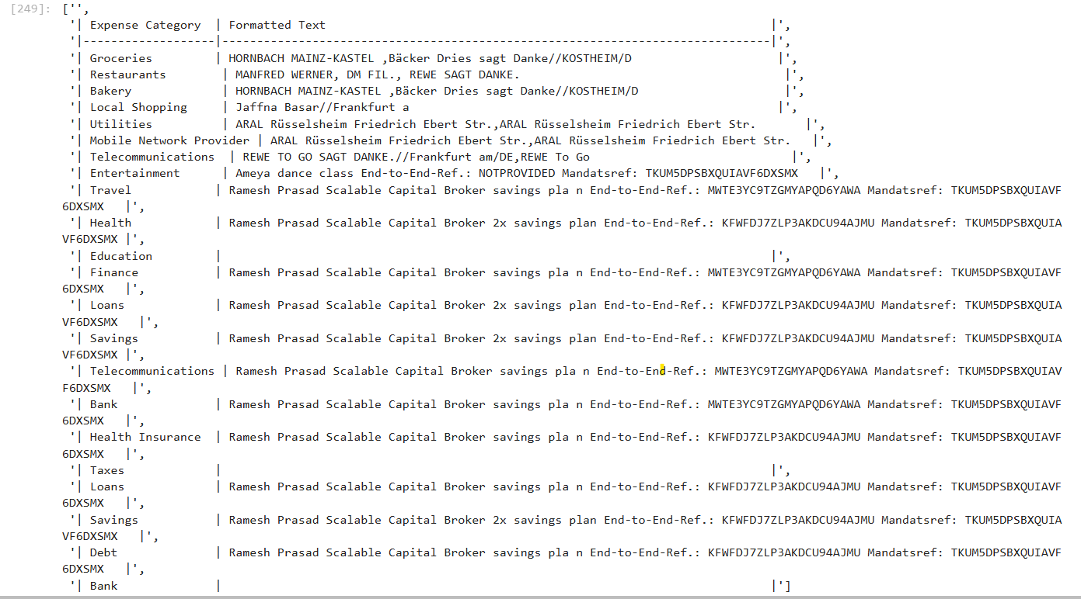

list_of_categories = ['Groceries', 'Utilities', 'Restaurants', 'Local Shopping', 'Telecommunications', 'Bakery','Mobile Network Provider', 'Entertainment', 'Travel', 'Health', 'Education', 'Finance','Loans','Savings']

prompt = llm.invoke(f"You are an AI trained to categorize expenses into the following categories: {list_of_categories}.The expected output is a format which repeats all rows and adds another column for the Formatted text seperated by , as categorized expense - based on what fits best to the list of possible expenses.categories should be less than four words."+ "," .join(unique_transactions[1:10]))

answer1 = llm.invoke(prompt)

answer1 = answer1.split('\n')

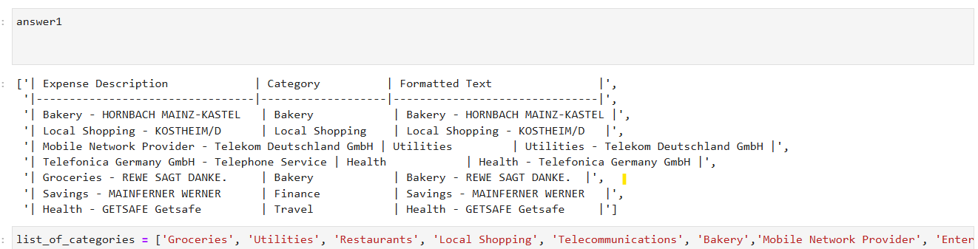

+++

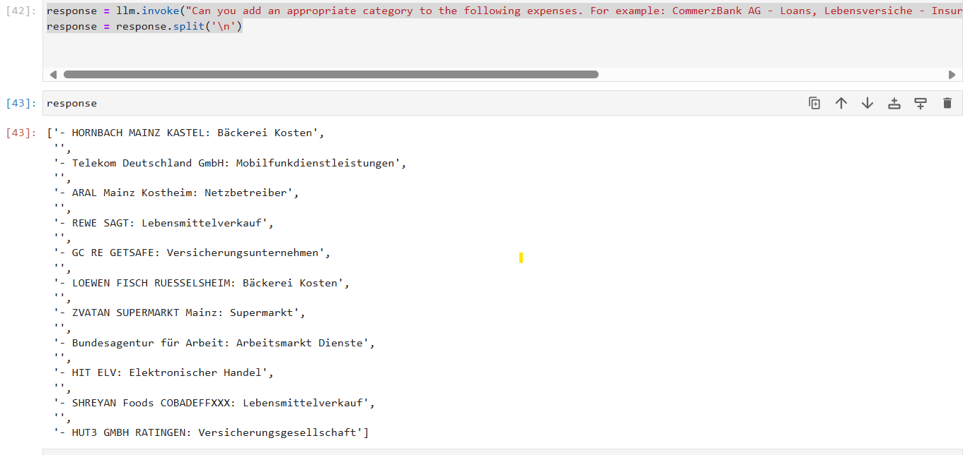

response = llm.invoke("Can you add an appropriate category to the following expenses such that the output translated to English seperated by -. For example: CommerzBank AG - Loans, Lebensversiche - Insurance, etc.. Categories should be less than 4 words. " + "," .join(unique_transactions[1:30]))

response = response.split('\n')

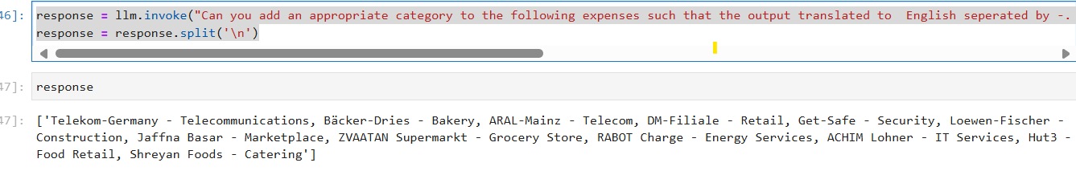

list_of_categories = ['Groceries', 'Utilities', 'Restaurants', 'Local Shopping', 'Telecommunications', 'Bakery','Mobile Network Provider', 'Entertainment', 'Travel', 'Health', 'Education', 'Finance','Loans','Savings']

response = llm.invoke(f"You are an AI trained to categorize expenses into the following categories: {list_of_categories}Can you add an appropriate category to the following expenses seperated by -. For example: CommerzBank AG - Loans, Lebensversiche - Insurance, etc.. Categories should be less than 4 words. " + "," .join(unique_transactions[1:30]))

response = response.split('\n')





